4.5 Triple Integrals

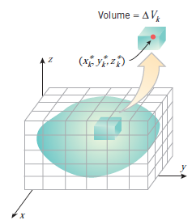
Motivation: Suppose we want to take an integral of a function of three variables, , over a rectangular box . There are several possible reasons for wanting to do this as we will see in this section.

Our strategy for doing this is analogous to what we did for double integrals. In particular we partition into l subintervals of length , we partition into m intervals of length , and we partition into n subintervals of length .
After this we have divided B into boxes with volume .

Definition: The triple integral of over the box B is
provided that the limit exists (where is a sample point in ).

Theorem (Fubini’s Theorem for Triple Integrals):
If is continuous on the rectangular box , then .

Note: The order of the differentials in the above theorem may be permuted as long as the limits of integration on each integral are changed as well.

Example 1:
- Suppose that B is a rectangular box. What is the geometrical meaning of the quantity ?

- Evaluate the triple integral exactly where .

We can extend our discussion of triple integrals to more complicated regions of integration.
Definition: A solid region E is said to be of type 1 if it lies between the graphs of two continuous functions of x and y. That is, if where D is the projection of E onto the xy-plane.

Note: The projection of a solid E onto the xy-plane is the set . Projections onto the xz-plane and yz-plane are defined similarly. Intuitively, the projection of a solid E onto the xy-plane is the resulting two-dimensional region if the z coordinate of every point in E became 0.

Note: Type 2 and type 3 regions are defined similarly to the type 1 region. In type 2 regions x is bounded by functions of y and z, and in type 3 regions y is bounded by functions of x and z.

Type 1 Region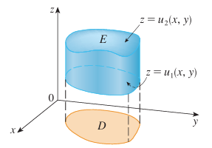 | Type 2 Region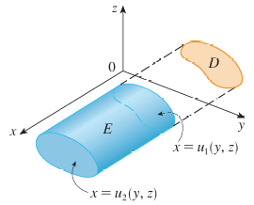 | Type 3 Region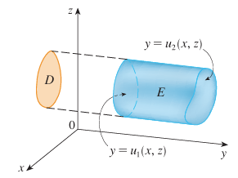

Extending the idea used in section 4.2 for double integrals, we get the following theorem.

Theorem: If E is a type one region: . Analogous results hold for type 2 and type 3 regions.

Note: A picture reflecting this theorem for Type 1, 2, & 3 regions are shown below.

Note: If D happens to be a two-dimensional type 1 or type 2 region, the above theorem makes it possible to evaluate triple integrals over regions more complicated than rectangular boxes.

We will now discuss a general procedure for setting up a triple integral as an iterated integral.

THE KEY TO GETTING GOOD AT SETTING UP TRIPLE INTEGRALS IS UNDERSTANDING THE GEOMETRY OF THE SITUATION AND THE INEQUALITIES INVOLVED.

Generally speaking, after we have the inequalities determining the region of integration and a picture of the region of integration, we follow one of the procedures below when setting up triple integrals for evaluation.
When working from a Picture of the Region of Integration:
- Determine if the region in question has a clear floor/ceiling (z-bounds), front/back (x-bounds), or left/right (y-bounds).

- Select one of these to be the innermost variable of integration and write down the appropriate bounds.

- Project the region of integration onto the appropriate plane. Draw a picture of the projection and write down the inequalities determining the projection.

- Set up the appropriate double integral (as an iterated integral) using the projection from 3.

When working with Inequalities describing the Region of Integration:
- Pick a variable to be the innermost variable of integration.

- Write down all the inequalities involving the variable chosen in 1. Choose the most restrictive inequalities for the upper and lower bound on the variable chosen in 1.

- Project the region of integration onto the appropriate plane. Draw a picture of the projection and write down the inequalities determining the projection (the inequalities determining the projection may always be deduced from the original inequalities).

- Set up the appropriate double integral (as an iterated integral) using the projection from 3.

Note: Both approaches have the same steps (3) & (4). The only difference is how we establish the bounds for the innermost variable of integration.

Note: In order to use second approach of working with inequalities you already need to have a sketch of the region and so, this can often times be more work than by just using the first approach.

Example 2: Evaluate where E is the solid tetrahedron bounded by four planes: , , , and .

Note: There are actually six different ways that the above integral could be set up. For example if we would have started by bounding x we would get . Then, after examining the projection onto the xz-plane we could have obtained the iterated integral: which yields the same answer.
Example 3: Set up but do not evaluate an iterated integral (in rectangular and in the specified order) which will yield the volume of the solid E which is bounded by the quadric surface and the plane .

- Set up the iterated integral so the differentials are in the order .

- Set up the iterated integral so the differentials are in the order .

Example 4: Consider the iterated integral . Rewrite this iterated integral so that the differentials are in the order: .

Using a Picture of the Region of Integration
Steps (1) & (2):
We don’t have a picture of the full region. We will construct a picture of this region by building off the projection region of D. We start by sketching a picture of D in 3-space within the xy-plane. We will think of this as the “foundation” of the solid that we are constructing. Based on the inequalities that we described above we know that in our region . This tells us about how the “floor” and “ceiling” of our region behave. We see that the “floor” of our region is constantly at , whereas the “ceiling” of the region changes heights and is given by the plane .

Since acts as the “floor” of our region we know that the region of D that we have sketched is the “floor” of our solid. To better understand the effects of the “ceiling” on our region, we will move along the edges of the region D and attempt “reach up” to touch the ceiling at every point.
